Communication preferences:
User Story: As a realtor, I want the CRM to display client preferences (e.g., DND status, mode of communication) in the client profile header, so that, I have instant access to critical information.
Assuming backend implementations are complete, customization to be done in the Salesforce org are given here.
- User must be able to see client’s communication preferences highlighted on the profile header when navigated to a lead or contact record page.
Based on the DND mode, comm preference and language, user can plan and contact the client accordingly.
Fields (highlighted in green) Do not Disturb; Communication Preferences and language should be displayed in the profile header as shown in the below screenshot.
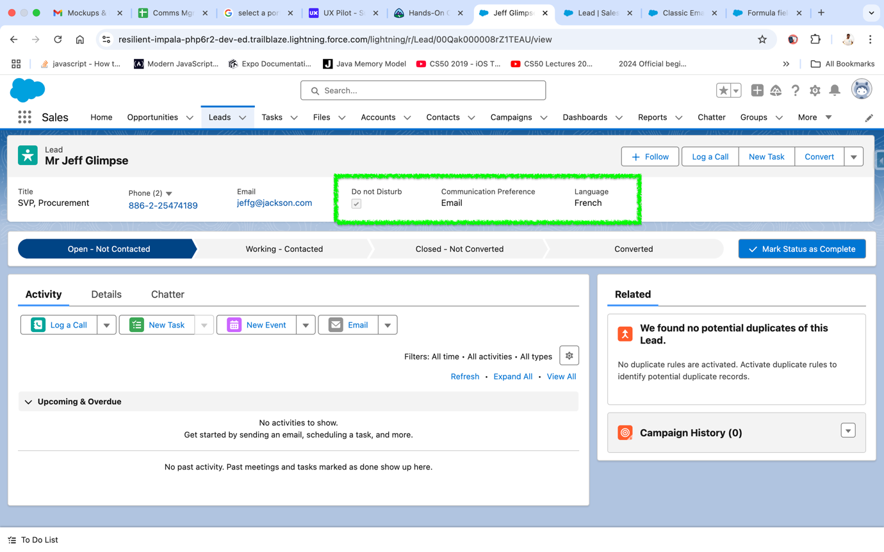

- Same fields (highlighted in green) must also be displayed in the mobile app screen as well. Sample screenshot given below.
